Health and History: Skeletons as Sources
- What were medieval hospitals?
The medieval hospital has little comparison to a modern hospital: they were religious institutions which also had a role in showing charity. The hospital gave shelter to people rather than giving medical care. We can still find reference to this in words like 'hospitality'.
Hospitals would have provided rest, warmth, protection and food. These things could have made a big difference to a poor person's suffering. Famine and illness were common throughout the medieval period, so finding shelter at a hospital could be the difference between life and death.
Hospitals were used by those most in need, including people who had leprosy, travellers, old people and those who were sick. Wealthier people gave gifts in return for prayers for the giver. This was a way to practise Christian charity.
Medieval hospitals were usually located on routes in and out of town, rather than being in the town's centre. The Hospital of St. John was founded on waste ground at the northern end of Cambridge around 1195. The hospital thrived until the mid 1300s and then slowly declined over many years. Eventually the hospital was disbanded and became part of St. John's College in 1511.
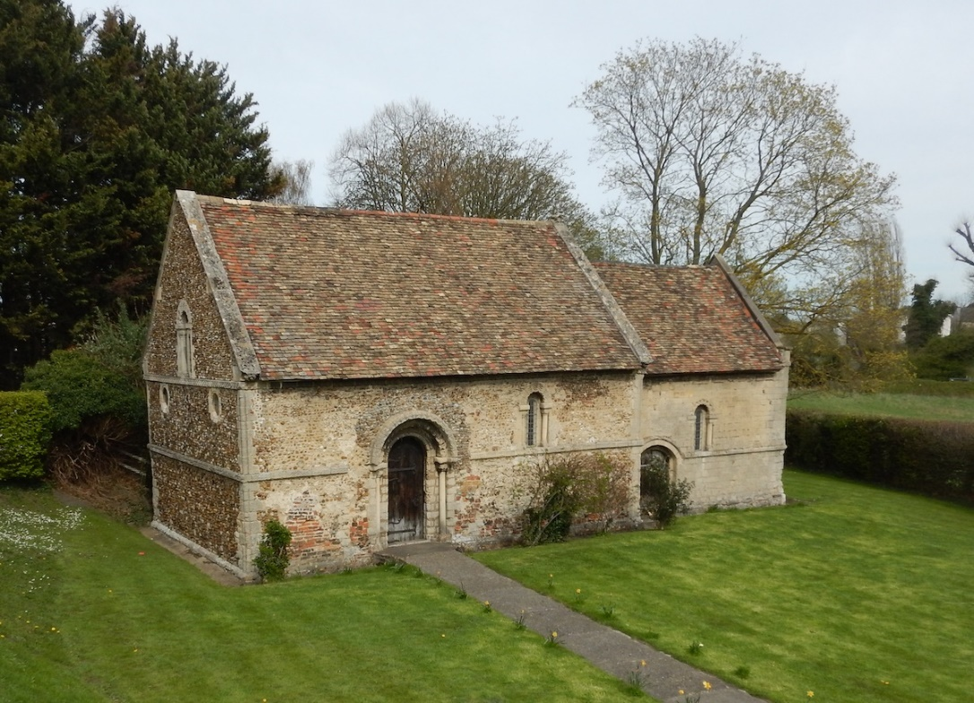
The Hospital of St. John probably gave 12 needy people a place to live. These people included poor people and those 'infirm', although the hospital rules stated that pregnant women, wounded people, as well as 'cripples and the insane' were not to be allowed in. Some people had a condition or illness that lasted a long time (chronic illness). Other people the hospital cared for were probably old and couldn't work and support themselves any more, they may not have had family to take care of them. The hospital was a religious establishment and people living there were expected to be Christian, to go to mass and to pray. When the cemetery was excavated both men and women were found to be buried there.
Figure 1. The Chapel of the Leper Hospital at Barnwell, Cambridge. Photograph: Cambridge Archaeological Unit.
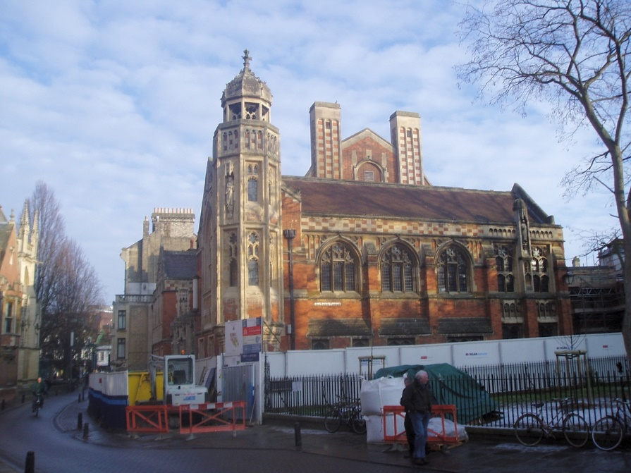
Figure 2. The Old Divinity School of St. John's College, the site of the medieval hospital cemetery. Photograph: Cambridge Archaeological Unit

