Health and History: Skeletons as Sources
- Excavating the cemetery at St. John's Hospital
In the early 2000s, St John's College planned to refurbish the Old Divinity School building to improve the facilities. Before they began, the Cambridge Archaeological Unit excavated the area under the building. They found around 400 burials and some artefacts.
Archaeologists think that around 1200-1500 people were buried in the cemetery in total, although the site had already been disturbed by Victorian builders while the Old Divinity School was being built.
On average 4-8 people per year were buried in the cemetery from around 1200 to 1350, but this went down to just to 1-3 burials every year from about 1350 to 1511.
Who was buried at St. John's Hospital cemetery?
The hospital could bury members and servants of the hospital, and people who were being looked after there and eventually died. People who gave lots of money to the hospital and senior members of staff were probably buried in the chapel, so we are unlikely to find their remains in this part of cemetery. It is most probable that the skeletons excavated by Cambridge Archaeological Unit were the sick and poor people of medieval Cambridge.
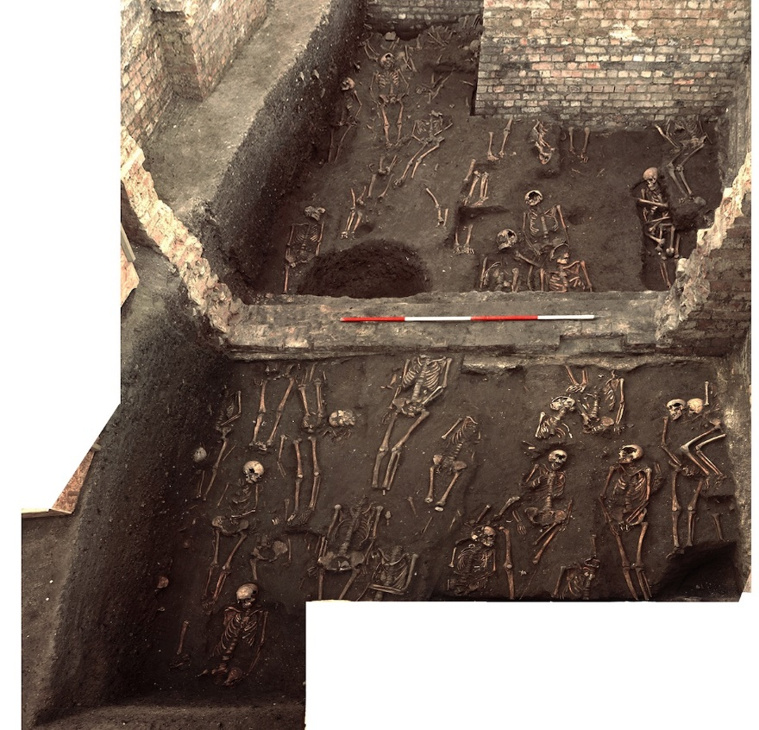
Figure 3. A bird's eye view of the excavation of the cemetery at St. John's Hospital. Photograph: Cambridge Archaeological Unit.
Before you continue with your research, take some time to consider the following questions:
What do you think would happen to the skeletons and artefacts after the excavation?
How should human remains be processed, assessed and reviewed?
What is the most important information to find out from the skeletons?
What further analysis of the site should take place?
What do you think should be recorded and archived?
Do you think all findings should be published?
Do you think it is right for human remains to go on public display?

