Health and History: Skeletons as Sources
4. Who were the people buried at St. John's Hospital cemetery?
Scientific study allowed experts to find out more about the individuals who were buried in the cemetery.
Find out more by clicking through the series of questions below.
How were people buried in the cemetery of St. John's Hospital?
By looking at the size and shape of the graves, archaeologists thought that most of the people buried there had not been put in a coffin. No archaeological evidence for coffins was found, but it is likely that the bodies had been wrapped in a shroud (a large piece of fabric) before they were put in the ground.
What were they buried with?
Medieval Christian burials usually did not include many objects in the grave with the dead person. Although about 400 skeletons were excavated at St. John's Hospital, only a few had objects with them. These may have been deliberately put with the bodies, but they might also have been left from earlier use of the site, or were even rubbish. There were only two items which the archaeologists could definitely conclude were grave goods and a third which was possibly from a grave.
The possible grave good was a cross-shaped pendant made of copper alloy metal. This was found with a small group of bones that had been wrapped in cloth. The cloth had been tied with a cord, and the pendant was discovered with that cord.
The two definite grave-goods were a metal brooch and a jet crucifix. The brooch was also made of copper alloy, and was found with the skeleton of a woman between the ages of 27 and 35 who was buried in the 15th century (1400s).
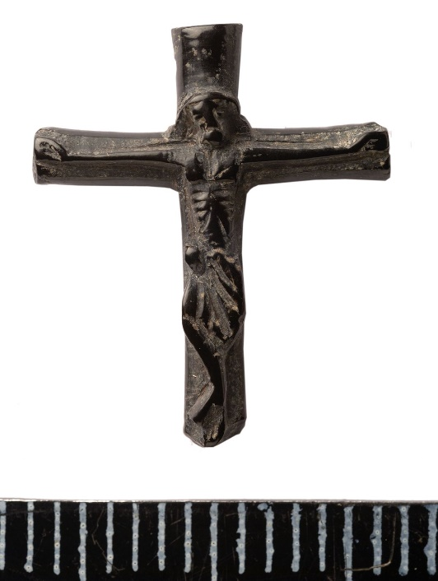
Figure 4. A jet crucifix, discovered during site excavations. Photograph: Cambridge Archaeological Unit

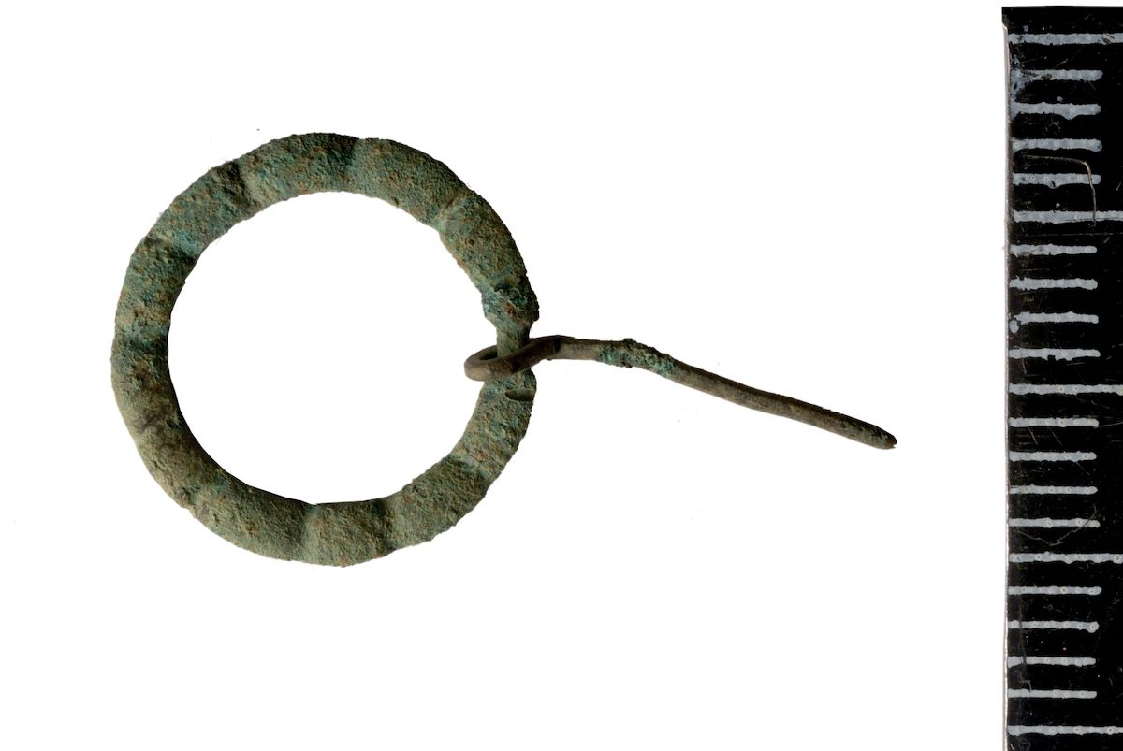
Figure 5. The brooch discovered during the excavation. Photograph: Cambridge Archaeological Unit.
The crucifix was made from Whitby jet and was found buried with a man. It is slightly broken but has been worn smooth, perhaps from being handled. Jet is a gemstone, formed over millions of years from fossilised wood. In the medieval period jet was ground to a powder to use as a tooth cleaner. Rubbing it against wool can make jet develop static charge, enough to pick up a light object. In the medieval period it was commonly thought of as a magical material and was sometimes used as a charm to keep sickness and evil influences away. This piece of jet had been carved into a religious symbol.
What sort of people were they?
Documents tell us that the Hospital would not admit particular groups of people, among them pregnant women, people who had leprosy, people with wounds or who were crippled. The people that were buried in the hospital cemetery were probably mostly poor.
Later in the Hospital’s lifetime, they accepted more people called ‘corrodians’. These were basically pensioners: older people who paid to stay in the hospital until they died.
There are very few documentary sources that archaeologists can read to understand who these individuals were. Records from the hospital no longer exist. The only way to find out about many of these people is by using archaeological techniques.
How can we find out more about them?
By comparing the archaeological evidence and written records of the time, we can begin to see how the average person may have lived, how they were treated when they were ill, and how they were looked after when they died (burial rites).
Medieval hospitals, like St. John's, did care for people, but in a spiritual sense rather than medical.
Can we create a biography of individual skeletons?
To write a biography, usually historians consult written documents: letter, wills, tax records. For these skeletons, the After the Plague project built a picture of that person’s life through their bones: an osteobiography (osteo- means relating to bones). Here we will show how the project put together one osteobiography.
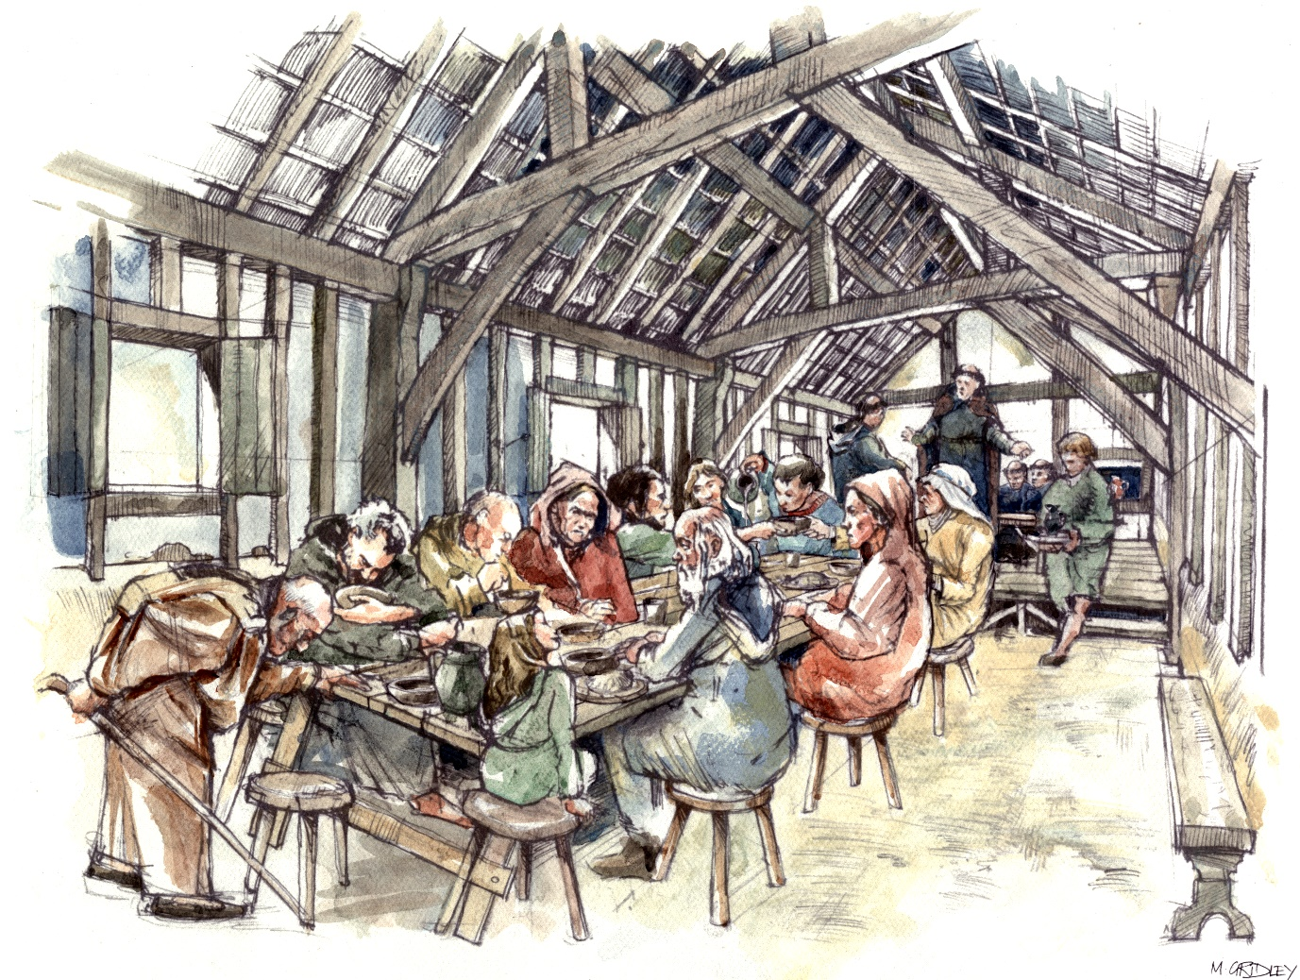
Figure 6. An artist's impression of the Hospital of St. John. Image: Mark Gridley.

