Health and History: Skeletons as Sources
5. Investigating a skeleton: A case study from St. John's Hospital cemetery
What do we know and how do we know it?
This skeleton was found buried face down. He is male; using radiocarbon dating it was determined that he lived in the 13th century (1200s). He was over 45 years old when he died.
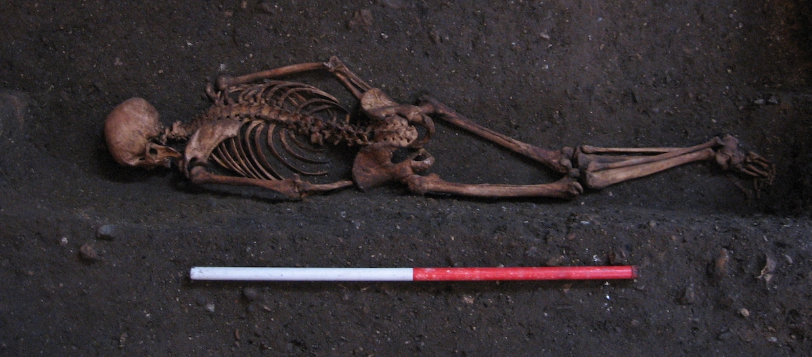
Figure 7. The skeleton in situ, discovered face down. Photograph: Cambridge Archaeological Unit.
By using different investigation techniques, scientists could begin to understand more about this person's life and possible ways they could have died. To find out more click through the series of questions below.
What can skeletal analysis tell us about his childhood?
Like a lot of children in the medieval period, there were a couple of times that his growth was interrupted - probably between birth up until he was 6 years old. This could have been due to illness, or not having enough to eat, but he had been strong enough to recover. Unlike half the population born at the same time as him, he survived his childhood. He grew up to be a tall man, one of tallest in whole cemetery (177.5cm). This was above average height for the time.
How can skeletal analysis tell us where he was from?
By studying his DNA, we discovered that his ancestors were probably from England. Analysis of his DNA shows that he is not closely related to anyone else buried in the cemetery.
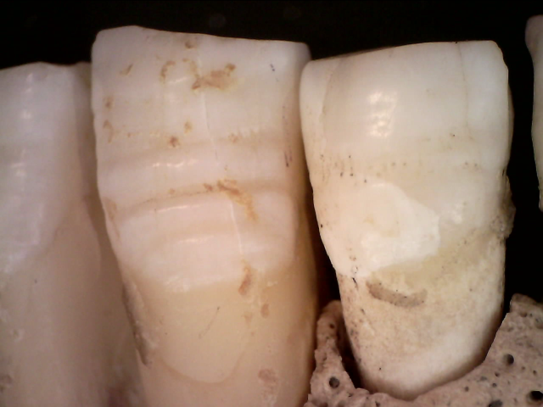
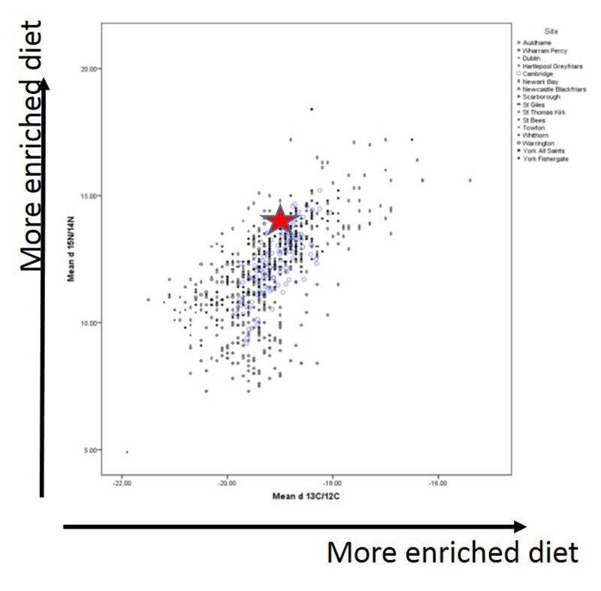
Figure 9. Growth interruptions show as ridges in the root of his tooth.
Figure 8. A graph showing that this skeleton (red star) had a richer diet than other people buried in the cemetery. Image: After the Plague
Can skeletal analysis tell us about the food he ate?
By looking at his bone chemistry, we can tell that his diet contained quite a few animal products, possibly fish. He would also have eaten an assortment of vegetables and grains, like most people in medieval Cambridge.
It is likely that he wasn’t in the hospital for a long time. Everyone in the hospital would have eaten the same diet and this probably didn’t include much meat.
Does this mean that he had a bit more money?
Was his job good enough for him to support himself (and his family, if he had any)?
Can skeletal analysis identify any illness or trauma?
His teeth were in quite bad condition, although would not have been uncommon at the time. He had cavities so would have known the pain of toothache, he also had a tooth abscess.
At some point in his life he had broken a rib and damaged the back of his skull. Both of these injuries had healed before he died.
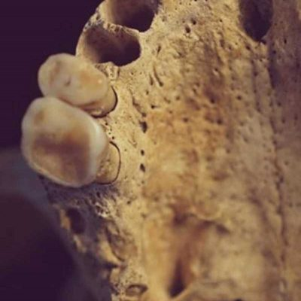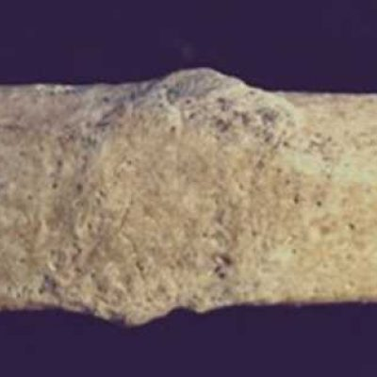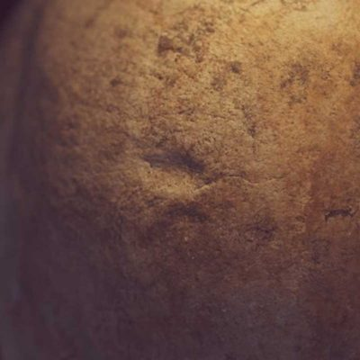
Can skeletal analysis tell us what sort of job he had?
He had a robust skeleton with strong muscles, showing he was physically active. He had a lot of lesions (areas of damage) on his spine, these may have occurred because his life involved a lot of lifting. It is highly likely that he did a repetitive activity which caused changes to his toes and feet.
Below is an artist's impression of how he may have looked. This is based on the analysis from the studies listed above.
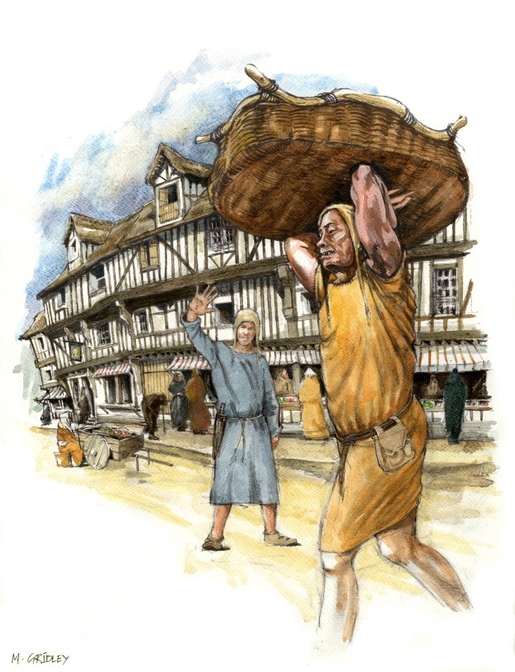
Figure 10. An artist's impression of the medieval man, based on skeletal and site analysis. Image: Mark Gridley.
What sort of job can you imagine him doing?
Can this analysis determine how the man died?
We cannot say how he died. Most causes of death leave no trace on bone. He may have had an illness, and with no family to care for him, perhaps he went to the hospital instead. It is also possible that he had worked at or had a link to the hospital and so got buried in its cemetery. It is unlikely that he was a monk or a scholar. What we do know is he was buried in a cemetery for poorer people.
Experts then find themselves asking the following questions:
Why was he buried face down?
Was it a hasty burial?
Or was he buried this way on purpose?
Was his position in the grave accidental?
Unfortunately not all questions can be answered, and the circumstances surrounding his death may never be known.
Further study of the skeleton allowed forensic experts to create a reconstruction of the skeleton's face. Below are some forensic reconstructions carried out by experts at the University of Dundee.
What differences do you see between the faces?
Do these reconstructions change the way you think about him?

