Health and History: Skeletons as Sources
Introduction:
How do historical conditions influence our health? How does health change history? The After the Plague Project investigates these questions by exploring health in medieval England (400-1500).
The most significant event during this period is the infamous Black Death (the plague epidemic of 1347-51), which killed 30% to 60% of Europe’s population. This project focusses on one medieval archaeological site in Cambridge, and the people who were buried there.
By working through this project, you will find out about a range of skills, strategies and methods which can be applied to your research or to artefacts you might see in museums and galleries. The resource has been written with reference to the A-Level Assessment Objectives to demonstrate how to plan and manage a research project and use a range of different resources.
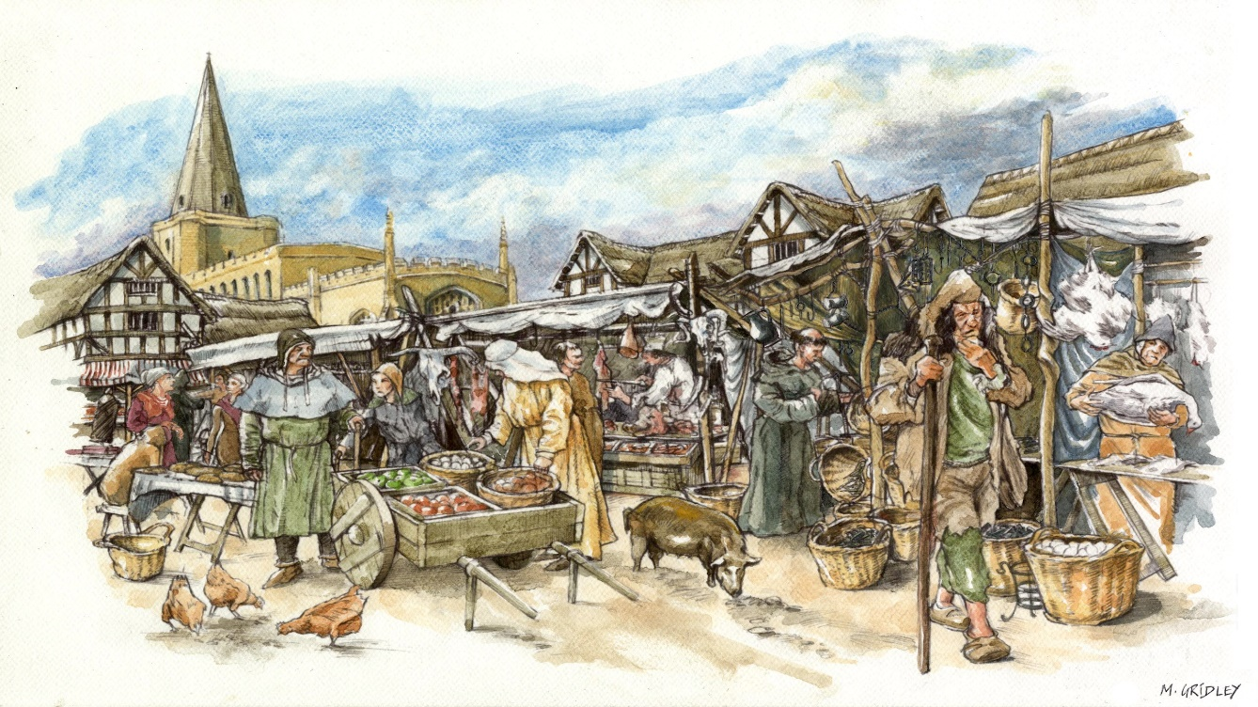
This website includes images of human remains.

